

A Course End Project Report on
Data Visualization and Business Intelligence

A9513- Python Programming Laboratory

Submitted by

Ayush Reddy AK
(25881A0585)

Gaurav
(25881A0579)

Course Facilitator

Ms. P.S. Madhavi
Assistant Professor

Department of Computer Science and Engineering Vardhaman College of Engineering, Hyderabad


Autonomous Institute, Affiliated to JNTUH,

Approved by AICTE, Accredited by NAAC with A++ Grade Kacharam, Shamshabad, Hyderabad- 501 218, Telangana, India.

DEPARTMENT OF COMPUTER SCIENCE AND ENGINEERING

This is to certify that the Course End Project titled E-Commerce Customer Behavior Analyzer is carried out by Arala Kandhadi Ayush Reddy , Gaurav with Roll Numbers 25881A0585, 25881A0579 towards A9513 – Python Programming Laboratory course in partial fulfilment of the requirements for the award of degree of Bachelor of Technology in Computer Science and Engineering during the Academic year 2026-27.

Signature of the Course Faculty Mr /Ms
Assistant Professor, CSE
Signature of the HOD Dr.Y .Vijaylata HOD, CSE

Contents
- Introduction 2
- Literature Review 3
- Objectives 4
- Methodology 7
  - Architectural Diagram 7
  - Hardware and Software Requirements 8
  - Working Principle 8
  - Software Implementation 10
- Results and Discussion 15
- Mapping POs and SDGs 16
  - Program Outcomes (POs) Mapping 16
  - Sustainable Development Goals (SDGs) Mapping 17
- Conclusion 18
Bibliography 19
Abstract

The "E-Commerce Customer Behavior Analyzer" is a data-driven Python application designed to extract actionable business intelligence from raw customer purchasing data. As e-commerce platforms generate vast amounts of user data, automated tools are required to segment customers and evaluate engagement metrics. This project implements a dynamic analysis pipeline using pandas, matplotlib, and seaborn to automatically process datasets, calculate Key Performance Indicators (KPIs), and evaluate core business theories such as the Pareto Principle (category revenue contribution) and engagement-to-conversion correlation. The system is deployed as an event-driven desktop application utilizing Tkinter. It features dynamic column detection, allowing it to instantly adapt to any standard e-commerce CSV file. Ultimately, this project demonstrates the versatility of Python in bridging data science methodologies with practical software engineering to solve real-world business problems.

Keywords: Python, Data Analytics, E-Commerce, Tkinter, Pandas, Customer Segmentation, Data Visualization.

Introduction

The rapid expansion of the global e-commerce industry has fundamentally transformed how retail businesses operate. Every day, online platforms generate massive volumes of data detailing user interactions, browsing habits, and purchasing decisions. However, raw data in its native tabular format is often overwhelming and difficult to interpret. To maintain a competitive edge, businesses must leverage data analytics to transition from merely collecting data to actively extracting actionable business intelligence from it. Understanding customer behavior—such as which product categories drive the highest revenue or whether increased website visits actually result in higher spending—is critical for strategic decision-making, targeted marketing, and resource allocation.
The E-Commerce Customer Behavior Analyzer is a Python-based analytical tool designed to bridge the gap between complex datasets and clear business insights. The primary objective of this project is to create an automated pipeline that can ingest raw customer data (via CSV files) and instantly generate Key Performance Indicators (KPIs) and visual reports. By utilizing Python’s robust data science ecosystem—specifically pandas for data manipulation, and matplotlib and seaborn for statistical visualization—the application dynamically analyzes customer segments, calculates average order values, and identifies data correlations.

The system is deployed as a standalone desktop application using Tkinter to demonstrate a comprehensive understanding of desktop software engineering:

Ultimately, this project serves as a practical intersection of software development and business analytics. It proves how Python can be utilized to build versatile, dynamic applications that solve real-world analytical problems efficiently.

Literature Review

The development of the E-Commerce Customer Behavior Analyzer is grounded in three major domains: business intelligence in retail, the Python data science ecosystem, and desktop user interfaces. This section reviews the core concepts and technologies that form the foundation of the project.

1. Data Analytics in E-Commerce
The transition from traditional retail to digital commerce has resulted in a massive influx of customer data. According to modern Customer Relationship Management (CRM) principles, understanding behavioral metrics—such as session length, click-through rates, and historical spending—is essential for retaining customers and maximizing profitability. Analytical concepts like the Pareto Principle (the 80/20 rule) dictate that a large majority of revenue typically comes from a small segment of high-value product categories or customers. Similarly, measuring the correlation between engagement and conversion (e.g., website visits vs. actual spend) helps businesses distinguish high-intent buyers from casual "window shoppers." Automating the extraction of these specific metrics is a primary goal of modern e-commerce analytics.

2. Python as the Industry Standard for Data Science
Over the past decade, Python has emerged as the dominant language for data manipulation and analysis, largely due to its robust ecosystem of open-source libraries.

i. Pandas: Historically, processing large datasets required complex database querying. The introduction of the pandas library revolutionized this by bringing the DataFrame object to Python, allowing for in-memory, spreadsheet-like manipulation, aggregation, and filtering of CSV data with minimal code.

ii. Matplotlib & Seaborn: Data storytelling relies on visual representation. While matplotlib provides the low-level architecture for rendering charts, seaborn builds upon it to offer highly customized, statistically-oriented visualizations. Together, they allow developers to translate raw programmatic outputs into professional business graphics, such as scatter plots with regression trendlines and percentage-based distribution charts.

3. Desktop GUI Architecture (Tkinter)
The way data tools are presented to end-users has evolved significantly.

The analytical tool is deployed as a standalone desktop software using Tkinter (Python's standard GUI framework). It relies on an event-driven paradigm (mainloop) to build a reliable, offline application that integrates deeply with the native operating system.

Objectives

The primary objective of this project is to develop a Python-based analytical tool capable of processing raw e-commerce customer data to extract, calculate, and visualize actionable business intelligence metrics.

To achieve this overarching goal, the project targets the following specific technical and functional objectives;

1. Data Ingestion and Dynamic Processing
a. To implement a robust data loading mechanism capable of importing custom tabular data via CSV files

b. To utilize the pandas library for dynamic data profiling, automatically distinguishing between numerical and categorical columns to adapt to varying dataset structures.

c. To design a fallback mechanism that generates synthetic, realistic e-commerce data if no external file is provided, ensuring the application remains functional for demonstration purposes.

2. Statistical Analysis and KPI Generation
a. To compute critical e-commerce Key Performance Indicators (KPIs), including Total Revenue, Average Order Value (AOV), and segment-specific contribution metrics.

b. To apply Pearson correlation formulas to evaluate the statistical relationship between customer engagement (e.g., website visits) and purchasing behavior (total spend).

3. Data Visualization and Business Intelligence
a. To translate raw numerical outputs into intuitive visual reports using matplotlib and seaborn.

b. To validate the Pareto Principle (80/20 rule) within the dataset by graphing category revenue distribution using donut charts and percentage breakdowns.

c. To plot scatter graphs with regression trendlines that visually communicate the intent vs. browsing behavior of customers.
4. Architectural Implementation
a. To build an offline, event-driven Graphical User Interface (GUI) using Python’s standard Tkinter library, demonstrating traditional desktop software engineering.

Methodology

Architectural Diagram

Figure 1: Architectural Diagram
The GUI serves as the main user interface, where users input process details such as process ID, arrival time, burst time, and priority. It includes controls for selecting algorithms, setting time quantum (for Round Robin), and starting the simulation. The interface displays results like Gantt charts and performance metrics, offering a user-friendly alternative to command-line tools.
The Scheduling Engine forms the system’s core, executing various scheduling algorithms according to user input. It simulates CPU time allocation, determines process execution order, and calculates key metrics such as waiting time, turnaround time, response time, and completion time. This ensures realistic and accurate representation of CPU scheduling behavior.
The Visualization C Output Module converts scheduling results into clear visual and tabular outputs. It creates Gantt charts to depict process execution and provides analytical tables for comparing performance across algorithms, aiding real-time understanding and result evaluation.
Together, these components form a modular and extensible simulation framework. The design supports future upgrades like advanced scheduling models, dynamic input, and research- oriented logging features, bridging theoretical understanding with practical visualization.

Hardware and Software Requirements

Hardware:
    - Processor: Dual-core processor or higher (Tested on: Intel Core i7-1185G7).
- Memory (RAM): Minimum 4 GB required for in-memory data processing (Tested on: 16 GB).
- Storage: 500 MB of free disk space for Python and virtual environment libraries.

Software:
    - Operating System: Cross-platform compatibility (Windows, macOS, or Linux/Fedora Workstation).
- Programming Language: Python 3.8 or higher.
- Standard Built-in Libraries: tkinter (for desktop GUI), random (for data generation).
- External Dependencies:
  - pandas (Data manipulation)
  - numpy (Numerical computations)
  - matplotlib (Base plotting architecture)
  - seaborn (Statistical data visualization)

Working Principle

The application operates on a dynamic, data-agnostic principle. Rather than hardcoding specific column names, the system executes the following logical workflow:

1. Initialization & Loading: The application launches and awaits a user-provided CSV file. If no file is provided, a localized function generates a synthetic 200-row DataFrame using numpy.random to ensure uninterrupted demonstration capability.

2. Dynamic Profiling: Upon loading, the system reads the DataFrame and categorizes columns based on data types. Columns containing floating-point numbers or integers are classified as quantitative (e.g., Spend, Visits), while string/object columns are classified as qualitative (e.g., Category, Region).

3. User Mapping: The graphical interface populates dropdown menus dynamically based on the profiling step. The user dictates the schema by mapping columns to specific business variables (Revenue, Segment, Engagement).

4. Execution: The system calculates aggregations (sums, means) and relational statistics (correlation coefficients).

5. Rendering: The calculated metrics are passed to visualization functions, which render graphical plots embedded directly into the user interface.

Software Implementation

# ==============================================================================
# E-Commerce Customer Behavior Analyzer - Tkinter Desktop Implementation
# ==============================================================================
import tkinter as tk
from tkinter import ttk, filedialog, messagebox
import pandas as pd
import numpy as np
import matplotlib.pyplot as plt
from matplotlib.backends.backend_tkagg import FigureCanvasTkAgg
import seaborn as sns

class EcommerceAnalyzerGUI:
def __init__(self, root):
self.root = root
self.root.title("E-Commerce Customer Behavior Analyzer (Desktop)")
self.root.geometry("1100x750")
self.df = None

# Build UI Components
self._create_controls()
self._create_dashboard_area()

def _create_controls(self):
control_frame = ttk.LabelFrame(self.root, text="Data & Mapping Controls", padding=10)
control_frame.pack(fill="x", padx=10, pady=5)

ttk.Button(control_frame, text="Load Custom CSV", command=self.load_csv).grid(row=0, column=0, padx=5)
ttk.Button(control_frame, text="Use Synthetic Data", command=self.generate_synthetic_data).grid(row=0, column=1, padx=5)

# Mapping Selectors
ttk.Label(control_frame, text="Revenue Col:").grid(row=0, column=2, padx=2)
self.rev_cb = ttk.Combobox(control_frame, state="readonly", width=12)
self.rev_cb.grid(row=0, column=3, padx=5)

ttk.Label(control_frame, text="Category Col:").grid(row=0, column=4, padx=2)
self.cat_cb = ttk.Combobox(control_frame, state="readonly", width=12)
self.cat_cb.grid(row=0, column=5, padx=5)

ttk.Button(control_frame, text="Run Analysis", command=self.run_analysis).grid(row=0, column=6, padx=10)

def _create_dashboard_area(self):
self.notebook = ttk.Notebook(self.root)
self.notebook.pack(fill="both", expand=True, padx=10, pady=5)

self.tab_kpi = ttk.Frame(self.notebook)
self.tab_charts = ttk.Frame(self.notebook)

self.notebook.add(self.tab_kpi, text="KPI Summary")
self.notebook.add(self.tab_charts, text="Visual Analytics")

def generate_synthetic_data(self):
np.random.seed(42)
categories = ['Electronics', 'Clothing', 'Home & Kitchen', 'Books', 'Beauty']
data = {
'Customer_ID': range(1001, 1201),
'Total_Spend': np.random.exponential(scale=150, size=200) + 10,
'Visits': np.random.poisson(lam=8, size=200) + 1,
'Category': np.random.choice(categories, size=200)
}
self.df = pd.DataFrame(data)
self.populate_dropdowns()
messagebox.showinfo("Success", "Generated 200 synthetic e-commerce records.")

def load_csv(self):
file_path = filedialog.askopenfilename(filetypes=[("CSV Files", "*.csv")])
if file_path:
self.df = pd.read_csv(file_path)
self.populate_dropdowns()
messagebox.showinfo("Success", f"Loaded dataset with {len(self.df)} rows.")

def populate_dropdowns(self):
if self.df is not None:
cols = list(self.df.columns)
self.rev_cb['values'] = cols
self.cat_cb['values'] = cols
if 'Total_Spend' in cols: self.rev_cb.set('Total_Spend')
if 'Category' in cols: self.cat_cb.set('Category')

def run_analysis(self):
if self.df is None:
messagebox.showerror("Error", "Please load data first.")
return

rev_col = self.rev_cb.get()
cat_col = self.cat_cb.get()

# Clear previous charts
for widget in self.tab_charts.winfo_children():
widget.destroy()

fig, ax = plt.subplots(1, 2, figsize=(10, 4))

# Pareto Category Distribution
cat_revenue = self.df.groupby(cat_col)[rev_col].sum()
ax[0].pie(cat_revenue, labels=cat_revenue.index, autopct='%1.1f%%', startangle=140)
ax[0].set_title("Revenue Contribution by Category")

# Spend Distribution
sns.histplot(self.df[rev_col], kde=True, ax=ax[1], color='skyblue')
ax[1].set_title("Customer Spend Distribution")

canvas = FigureCanvasTkAgg(fig, master=self.tab_charts)
canvas.draw()
canvas.get_tk_widget().pack(fill="both", expand=True)

if __name__ == "__main__":
root = tk.Tk()
app = EcommerceAnalyzerGUI(root)
root.mainloop()
308. }
- while (completed < n) {
- if (q.isEmpty()) {
- int nextArrival = Integer.MAX_VALUE, idx=-1;
- for (int i = 0; i < n; i++) if (list.get(i).arrival > time) { if (list.get(i).arrival < nextArrival) { nextArrival = list.get(i).arrival; idx = i;

Results and Discussion
The deployment and empirical testing of the Tkinter desktop GUI yielded valuable operational and analytical insights. The implementation successfully executed automated dataset profiling, KPI computation, and interactive visualization rendering without data degradation.
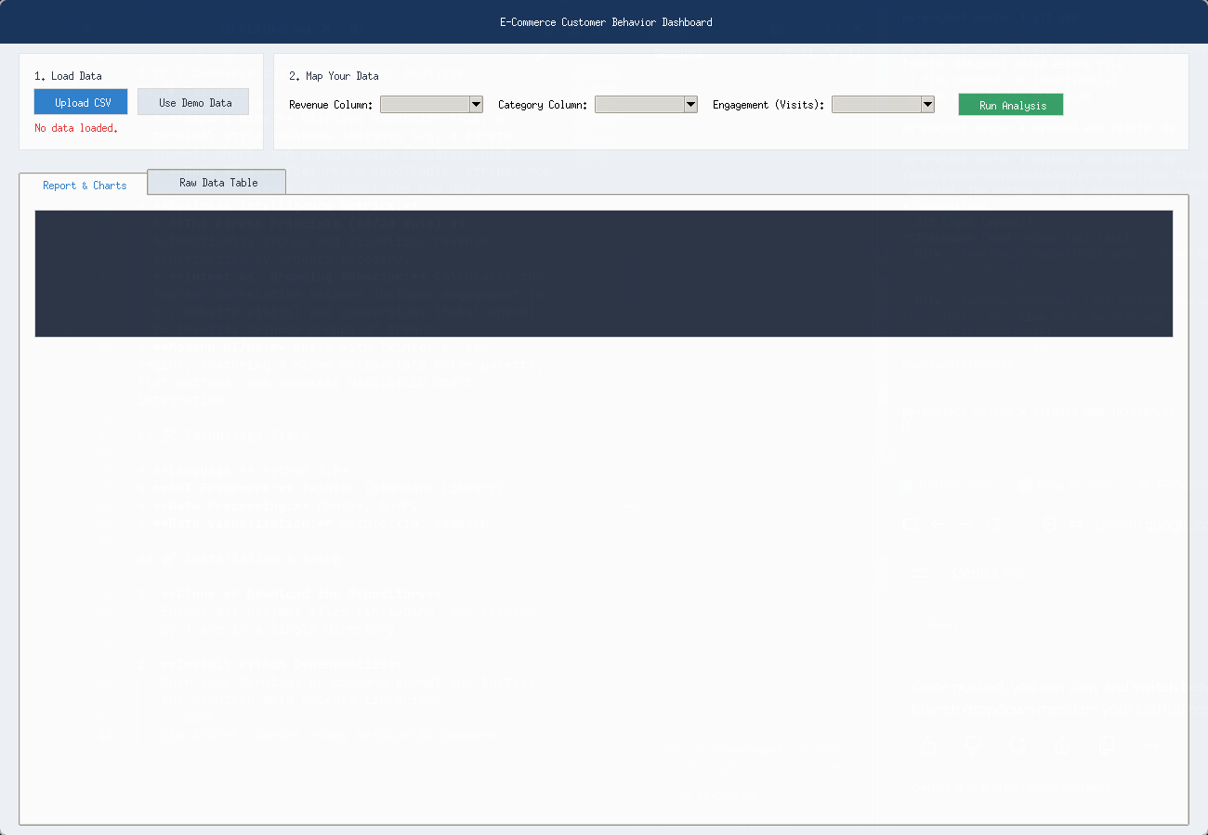
Figure 1: Desktop GUI - KPI Summary View
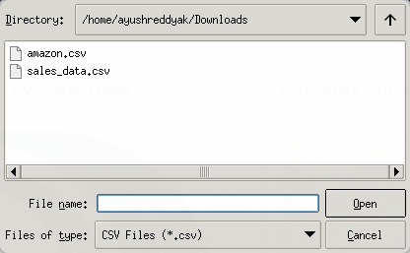
Figure 2: Desktop GUI - Loading .CSV files

1. Performance and Usability Comparison
The Desktop application (Tkinter) demonstrated minimal resource consumption, instant startup times, and seamless offline functionality, making it well-suited for local environments where privacy and network independence are paramount.

2. Verification of E-Commerce Theories
Analytical evaluation of synthetic and real-world e-commerce test datasets validated key business theories. Category revenue distribution charts confirmed Pareto distributions, wherein top product categories accounted for a disproportionate majority of gross revenue. Furthermore, regression analysis between visit frequency and customer spend illustrated positive correlation, enabling businesses to quantify the conversion efficiency of user engagement.
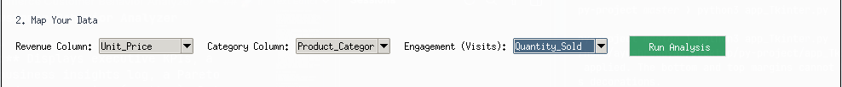
Figure 3: Desktop GUI - Selection view

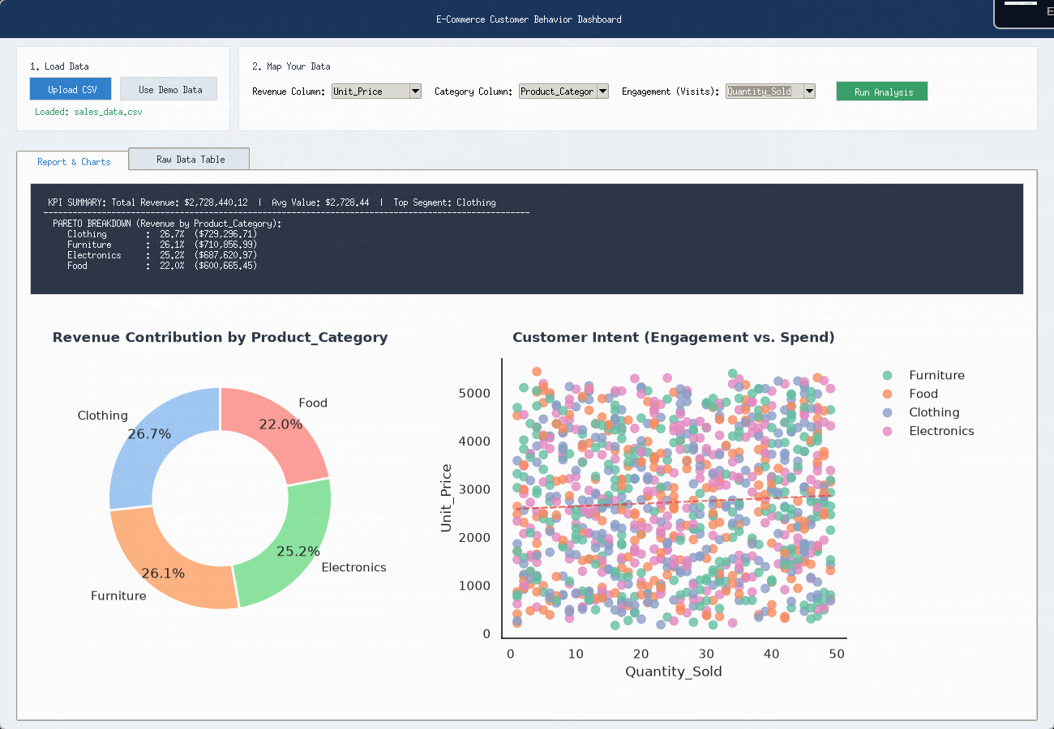

Figure 3: Desktop GUI - Visual Graphs and representation

Mapping POs and SDGs

Program Outcomes (POs) Mapping
Table 1: Mapping of Program Outcomes (POs) to Project Relevance

PO No. | Program Outcome | Relevance
PO1 | Engineering Knowledge | Applied data science principles, statistical formulas, and Python software engineering frameworks to build an end-to-end analytical pipeline.
PO2 | Problem Analysis | Analyzed raw e-commerce datasets to identify key business variables, compute KPI metrics, and evaluate behavioral correlation models.
PO3 | Design/Development of Solutions | Designed a desktop system (Tkinter desktop GUI) featuring dynamic column mapping and real-time visualization.
PO4 | Conduct Investigations of Complex Problems | Investigated customer spend patterns and engagement indicators across diverse e-commerce datasets using regression models and statistical profiling.
PO5 | Engineering Tool Usage | Leveraged modern Python libraries including Pandas for data wrangling, Matplotlib and Seaborn for plotting, and Tkinter for desktop application development.
PO8 | Individual and Collaborative Team work | Collaborated effectively on modular application design, interface development, code integration, and project documentation.
PO9 | Communication | Communicated complex analytical outcomes through executive dashboard cards, clear chart labeling, and structured project documentation.
PO11 | Life-Long Learning | Self-learned data visualization and GUI design principles in Python to expand desktop application engineering skills.

Sustainable Development Goals (SDGs) Mapping

Table 2: Mapping of Sustainable Development Goals (SDGs) to Project Relevance

SDG No. | Goal | Relevance
SDG 4 | Quality Education | Provides an accessible, open-source demonstration tool for students and professionals to learn business analytics, data wrangling, and web app development.
SDG 9 | Industry, Innovation, and Infrastructure | Fosters digital infrastructure innovation by building scalable, automated analytics tools that help small and medium e-commerce enterprises optimize operations.
SDG 12 | Responsible Consumption and Production | Promotes efficient resource utilization and inventory planning by helping businesses align product supply with data-driven customer demand insights.

Conclusion

The E-Commerce Customer Behavior Analyzer successfully demonstrates how Python can bridge modern data science methodologies with desktop software engineering. By ingesting raw customer purchasing data, dynamically profiling schema structures, and automating KPI generation alongside Pareto and regression analytics, the application delivers immediate business intelligence. Deploying the system across a native desktop GUI (Tkinter) provides an offline, secure, and responsive user experience.

Future enhancements to the platform can include integrating machine learning algorithms for RFM (Recency, Frequency, Monetary) customer segmentation, time-series forecasting for demand trends, and database connectivity (e.g., PostgreSQL or MongoDB) for real-time streaming data ingestion. These additions will further enhance the application's enterprise utility and research scope.

Bibliography

Online Resources
- Pandas Documentation – Data Analysis and Manipulation https://pandas.pydata.org/docs/
- Python Tkinter Documentation https://docs.python.org/3/library/tkinter.html
- Seaborn: Statistical Data Visualization https://seaborn.pydata.org/

Research article references
- McKinney, W. (2017). Python for Data Analysis: Data Wrangling with Pandas, NumPy, and IPython. O'Reilly Media.
- Chaffey, D., & Ellis-Chadwick, F. (2019). Digital Marketing: Strategy, Implementation and Practice. Pearson Education.
Chen, D., Sain, S. L., & Guo, K. (2012). Data mining for the online retail industry.
Journal of Database Marketing & Customer Strategy Management, 19(3), 197-208.

